Task 1

1. List all directors who were born in USA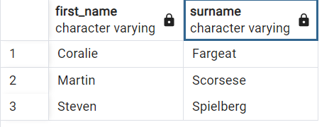
2. Which movies are directed by Coralie Fargeat 
3. List all the actors who played in the movies for which the cost of production was more than $1M. Compute cost in other currencies:

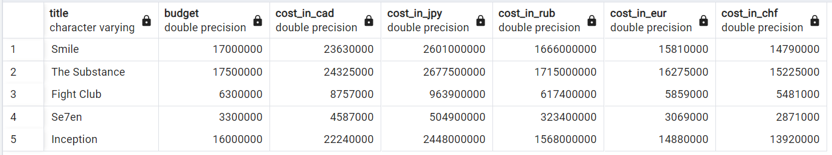

1. Find all the directors whose surname start with letter "A" and "F"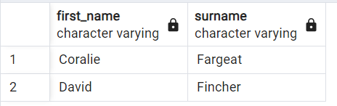
2. Find all the horror movies with a playing actor who is less than 40 (age)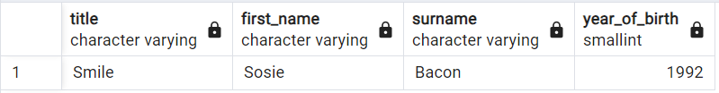
3. Find all pairs of actors who have blue eye colour in alphabetic order 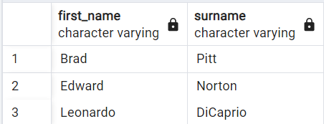

TASK 2

1. From the table Actors find the average age.
2. Find the number of different countries in which actors from the movie “Smile” were born

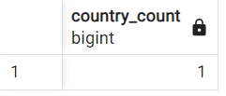

1. Find the number of actors with green eye colour

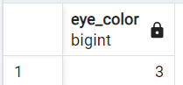

1. What is the number of movies in which Brad Pitt was playing? 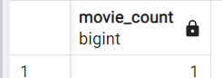
2. Find the minimum, average and maximum budget for each type of movie.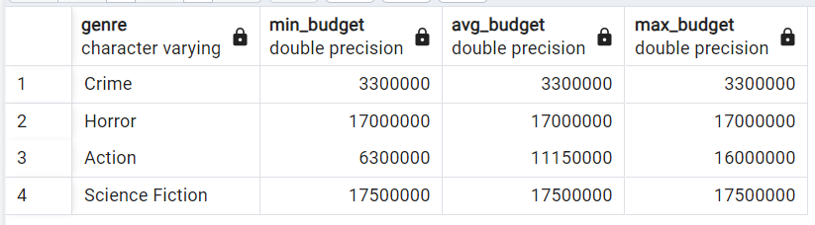
3. Find the average rating for each movie which has director born in New York or green eye color.



1. Find all the movies that have actors born in at least two different countries.

(none with dataset)

1. Find how many awards each movie in total has received and rank the movies (display the title) by the amount of awards 